**Assignment B: Test Driven Development**

**Presented to Professor Robert Sabourin**

**For the course ECSE 428: Software Engineering Practice**

**On March 4th, 2018**

**Presented by:**

**HUANG, Yin Jun – 260743592**

**LEI, Jun Yu – 260738036**

**Table of Contents**

Test 1: validInputTest 3

Test x: Valid Uppercase/Lowercase From and To Postal Code 6

Test x: Valid Uppercase/Lowercase Post Type 7

Test x: noArgumentTest 7

Test x: Less than 7 arguments 7

Test x: More than 7 arguments 7

Test x: Invalid From Postal Code 7

Test x: Invalid To Postal Code 7

Test x: Invalid Post Type 7

Test x: Non-Existent Valid From Postal Code 8

Test x: Non-Existent Valid To Postal Code 8

Test x: Non-Matching From and To Postal Code 8

Test x: Invalid Dimensions 8

Test x: Invalid Weight 8

Test x: Less or Equal to Zero Dimensions 9

Test x: Less or Equal to Zero Weight 9

Test x: Over Max Dimensions 9

Test x: Over Max Weight 9

# Test 1: validInputTest

Purpose: Verify postal rate calculator logic works for a valid set of user inputs.

Setup: P0B1L0 H4A1H3 xpress 15 15 15 15

Expected Result: 26.85

Failing Screen Shot

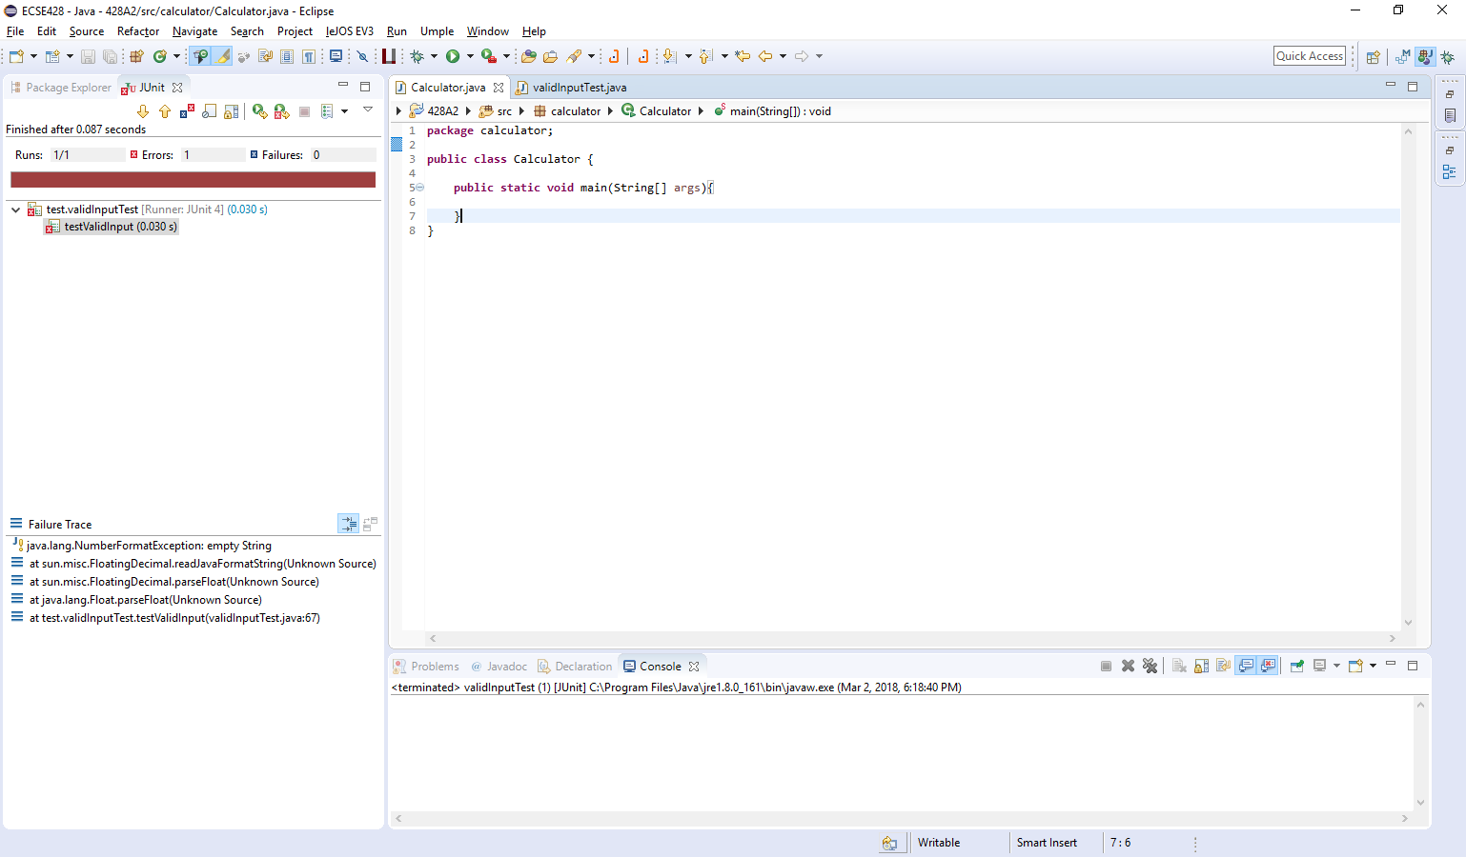

Succeeding Screen Shot

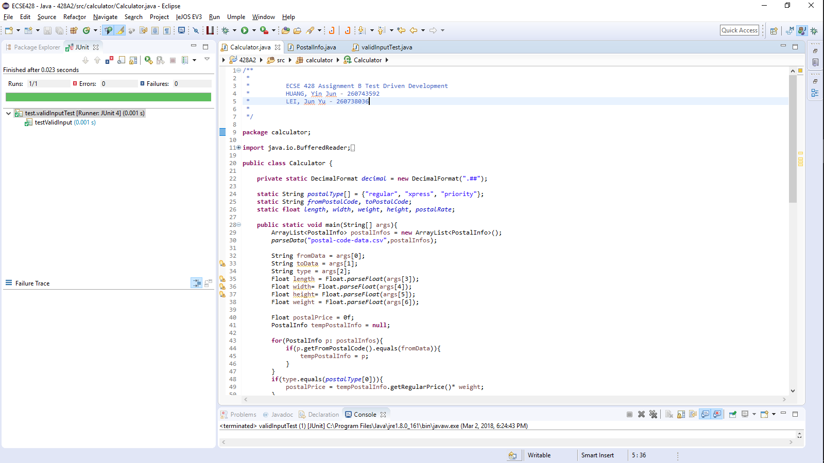

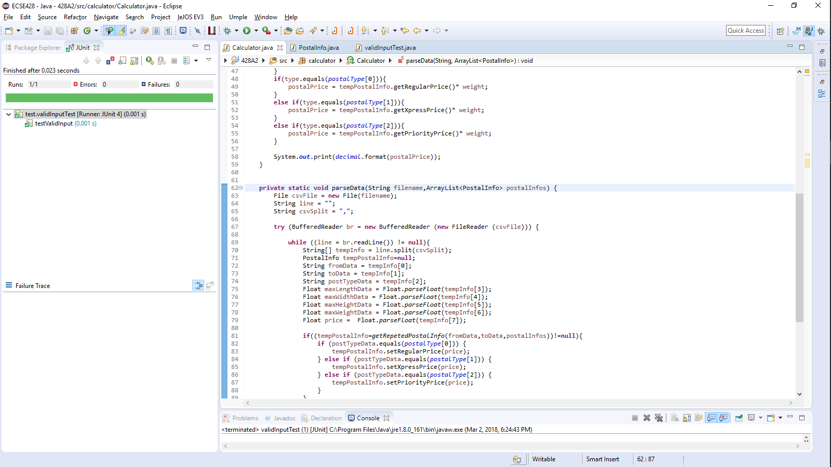

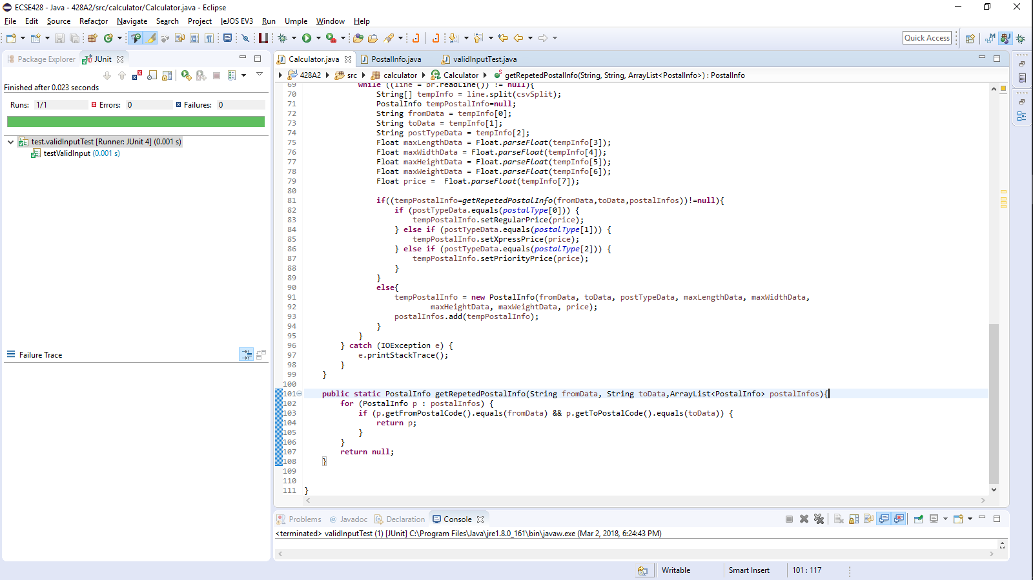

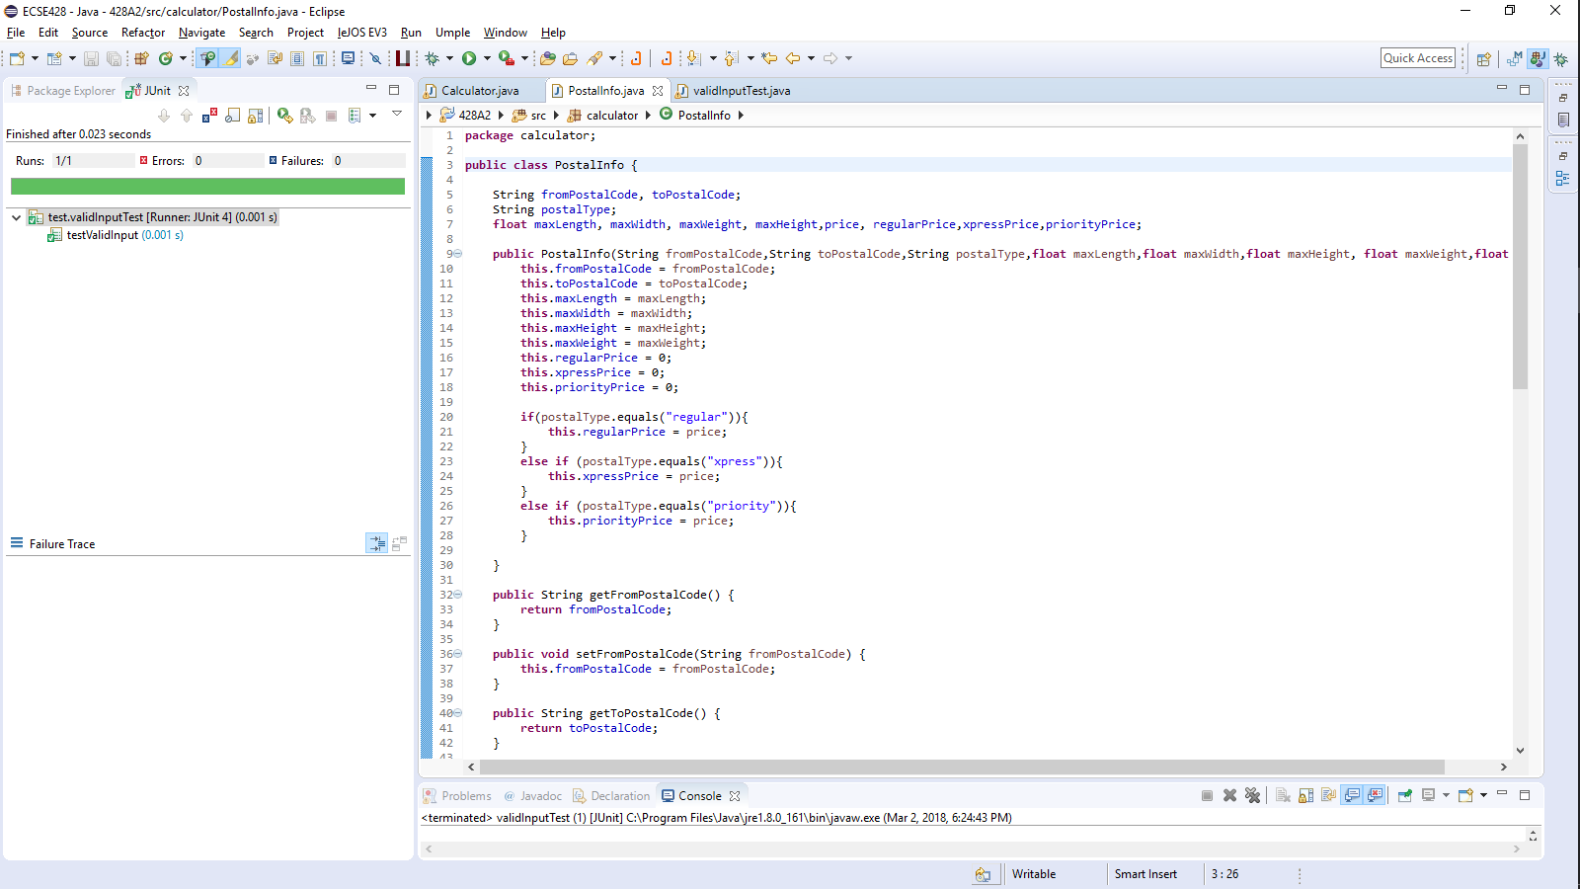

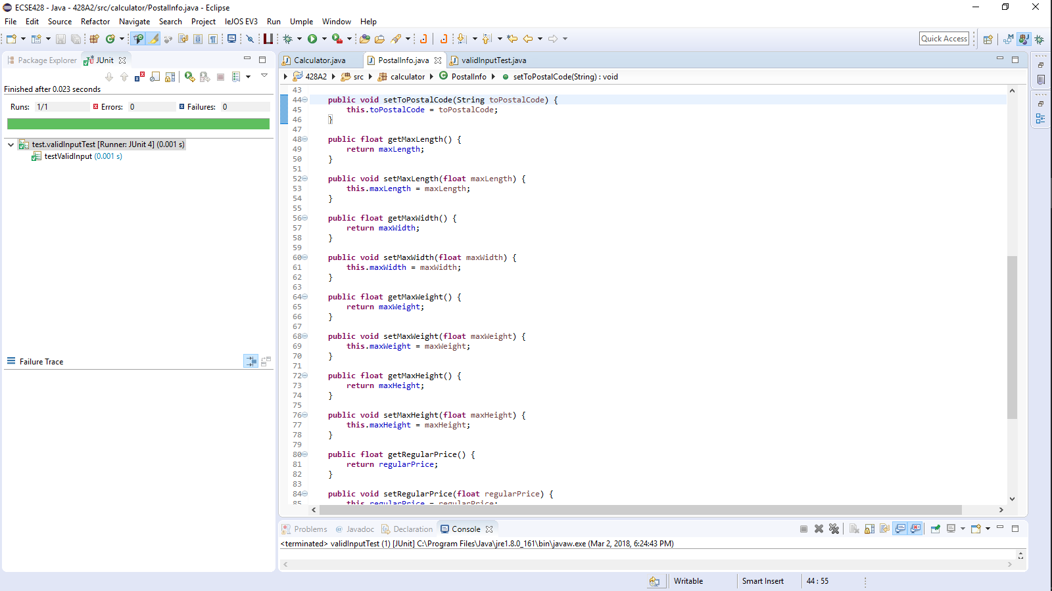

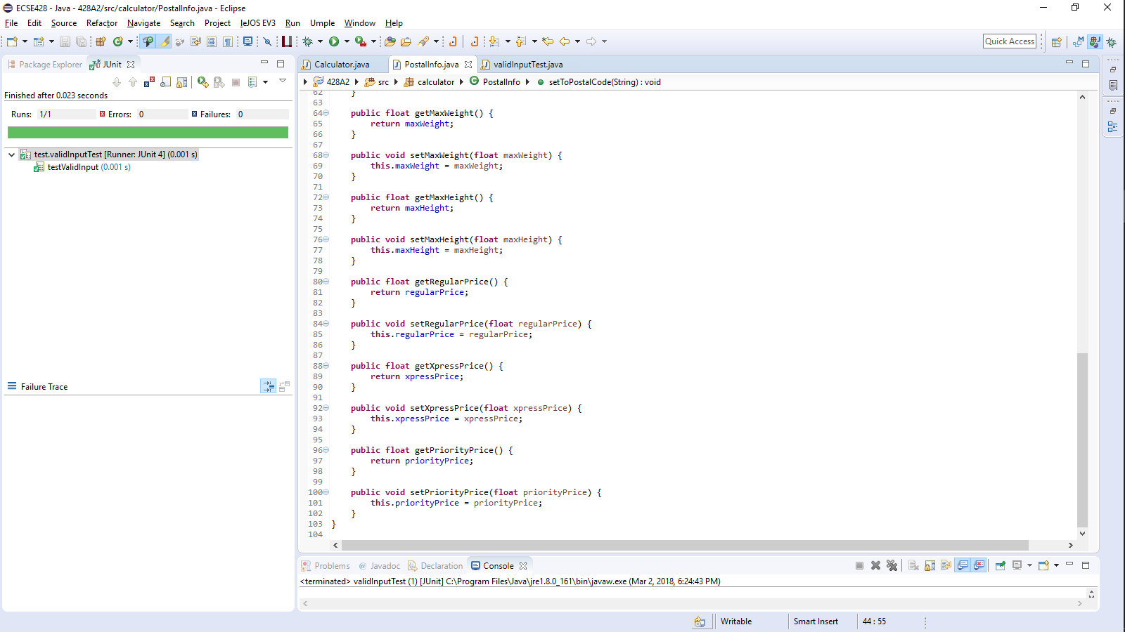

# Test x: Valid Uppercase/Lowercase From and To Postal Code

Description:

Setup:

Expected Result:

Failing Screen Shot

Succeeding Screen Shot

# Test x: Valid Uppercase/Lowercase Post Type

Description:

Setup:

Expected Result:

Failing Screen Shot

Succeeding Screen Shot

# Test x: noArgumentTest

Description:

Setup: Calculator

Expected Result: “Usage: Calculator fromPostalCode toPostalCode postType length width height weight”

Failing Screen Shot

Succeeding Screen Shot

# Test x: Less than 7 arguments

Description:

Setup:

Expected Result:

Failing Screen Shot

Succeeding Screen Shot

# Test x: More than 7 arguments

Description:

Setup:

Expected Result:

Failing Screen Shot

Succeeding Screen Shot

# Test x: Invalid From Postal Code

Description:

Setup:

Expected Result:

Failing Screen Shot

Succeeding Screen Shot

# Test x: Invalid To Postal Code

Description:

Setup:

Expected Result:

Failing Screen Shot

Succeeding Screen Shot

# Test x: Invalid Post Type

Description:

Setup:

Expected Result:

Failing Screen Shot

Succeeding Screen Shot

# Test x: Non-Existent Valid From Postal Code

Description:

Setup:

Expected Result:

Failing Screen Shot

Succeeding Screen Shot

# Test x: Non-Existent Valid To Postal Code

Description:

Setup:

Expected Result:

Failing Screen Shot

Succeeding Screen Shot

# Test x: Non-Matching From and To Postal Code

Description:

Setup:

Expected Result:

Failing Screen Shot

Succeeding Screen Shot

# Test x: Invalid Dimensions

Description:

Setup:

Expected Result:

Failing Screen Shot

Succeeding Screen Shot

# Test x: Invalid Weight

Description:

Setup:

Expected Result:

Failing Screen Shot

Succeeding Screen Shot

# Test x: Less or Equal to Zero Dimensions

Description:

Setup:

Expected Result:

Failing Screen Shot

Succeeding Screen Shot

# Test x: Less or Equal to Zero Weight

Description:

Setup:

Expected Result:

Failing Screen Shot

Succeeding Screen Shot

# Test x: Over Max Dimensions

Description:

Setup:

Expected Result:

Failing Screen Shot

Succeeding Screen Shot

# Test x: Over Max Weight

Description:

Setup:

Expected Result:

Failing Screen Shot

Succeeding Screen Shot